COVID-19 Detection in Chest X-rays

Master of Data Science Practicum

Illinois Institute of Technology

May 3rd, 2021



INTERNAL TEAM

Olugbenga Abdulai

Kinjal Kachi

Sujay Puvvadi

ACCENTURE TEAM

Executive sponsor: Thomas Kawalec

Internal MD sponsor: Sanjay Jaiswal

Project Lead: Mrugami Mahadik

Offshore advisor: Anup Nair

# Project Background

## Sponsor and Line of Business

* Accenture
* Accenture is a global professional services company with leading capabilities in digital, cloud, and security. It provides consulting services to various kinds of clients in different domains including healthcare, which is the domain for this problem.

## Description of Sponsor’s Problem

## Radiological images continue to grow at a significant rate compared to the number of trained radiologists/readers available.

* It is estimated that in some cases, an average radiologist must interpret one image every 3–4 seconds in an 8-hour workday to meet workload demands.
* AI-driven radiological image analysis has the potential to increase efficiency & reduce errors by providing trained radiologists with, in some cases, superior detection capabilities [1].
* Use AI-driven image recognition for COVID-19 detection.

## Data

* Source: Kaggle datasets [2]
* A collection of grayscale images each belonging to one of 3 classes - Normal, COVID, and Viral Pneumonia.

# Project Objectives and/or Goals

## Project Objectives

* Apply deep learning to solve the image recognition machine learning problem.
* Develop and deploy a high-performance and optimized machine learning model as a web application.
* Explore neural network interpretability to gain intuition on how and why the model is making its predictions.

## Delivered Objectives

* All objectives were delivered.

# Project Deliverables

## Description of Deliverables

* Well-documented code
* Deployed model
* Final presentation
* Final report

## Availability of Deliverables

* All expected deliverables are accessible by the Accenture team via the company’s analytics projects dashboard. A tool that supports version control.
* The internal team has permanent access to the code via a GitHub repository [3].

# Project Complications and Constraints

## Complications

* Given the computer demands of convolutional neural networks (high RAM, powerful GPU), some team members had to resort to working on Google Colab rather than locally.
* For the team members that worked locally, we still had to reduce the batch size to 32 for training the deep neural networks due to RAM limitations.
* One of the team members was initially working remotely for a short while in a very different timezone and it was challenging to set up meetings.

## Constraint

* Data limitation - COVID X-ray images are not at all ubiquitous. We had about 1200 images and this is rather small for a deep CNN. While we achieved great results, it may not generalize as well as a case with more images.

# Project Execution

## Agile Development: Epic, Story, Task Completed

|  |  |  |
| --- | --- | --- |
| **Epic** | **Story** | **Task** |
| Data Preparation and analysis | * Source data | * Get data from Kaggle datasets |
|  | * Exploratory Data Analysis | * Analyzing and visualizing any meaningful patterns in images across different classes |
|  | * Pre-processing | * Standardizing, resizing, and enhancing images * Pre-modeling steps such as batching, shuffling, and prefetching * Split the dataset into train, test, and validation sets |
| Model Building | * Build Base Model | * Choose appropriate metrics - Precision, Recall, Accuracy, F-1 score * Train a base CNN model and evaluate the performance |
|  | * Model Selection and tuning | * Develop more complex models with transfer learning * Select optimal model from the pool of candidate models |
|  | * Evaluation | * Use test set for final evaluation * Analyze errors the final model makes on the test set |
| Model Interpretability | * Analyzing intermediate CNN outputs | * Obtain and analyze intermediate feature map visualizations |
|  | * Class activation mapping | * Consider gradient weighted class activation mapping to obtain heatmaps |
| Model Deployment | * User interface design | * Design a mock-up of user interface * Develop user interface for the web application using elements like HTML and CSS |
|  | * Backend development | * Develop data processing pipelines * Load model for predictions * Cater for downloading results as a csv file |
| Documentation | * Code * Final report * Final presentation | * Add comments to code and perform code cleanup * Develop final report and presentation |

## Findings, Results

Exploratory Data Analysis

* The distribution of classes is shown below. The data is roughly balanced. 1341 normal images, 1345 viral pneumonia images, and 1200 COVID images.

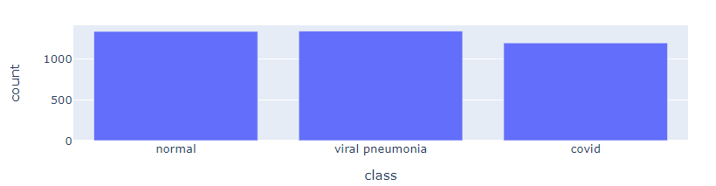

* The data format used for all analysis is the TensorFlow dataset format.
* All images are in png format.
* Images are resized to 224 x 224 pixels each and standardized to a 0-1 range.
* A random sample of images is shown in the figure below:

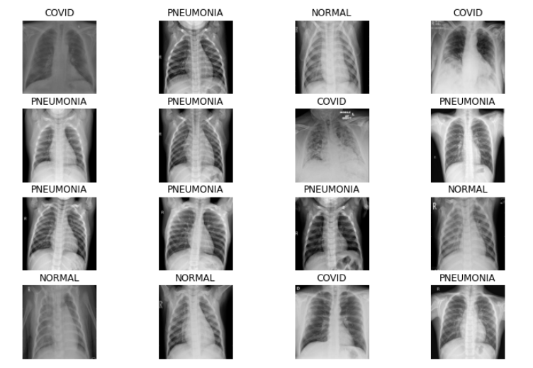

* We analyzed pixel averages across images in each class and obtained the results as shown below:

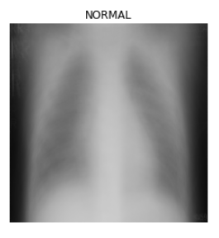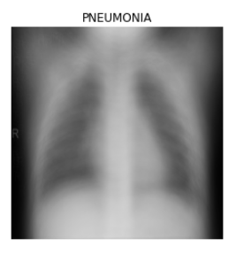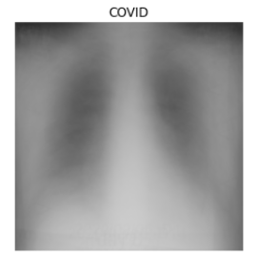

* We did a similar analysis for pixel variability across images in each class and obtained the results as shown below:

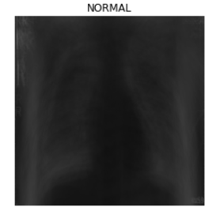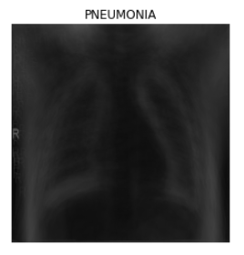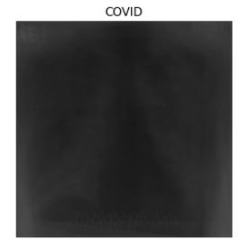

* In both of these results, it appears that the COVID images look more white-washed on average across all images in the dataset.

Modeling

*Base model*

* A shallow convolutional neural network with 7 convolution layers, max-pooling layers, dropout regularization, batch normalization, and 3 dense layers.
* The output layer is a softmax layer with 3 units.
* The optimizer used is the Adaptive Moments optimization algorithm (Adam) with a learning rate of 0.0006
* Loss function to minimize is the sparse categorical cross-entropy.
* Metric to optimize is accuracy.
* Callbacks are used to schedule the learning rate, save the model at checkpoints in case of failure, and to regularize with early stopping.
* Training was done for 30 epochs.
* A summary of the model is shown below.

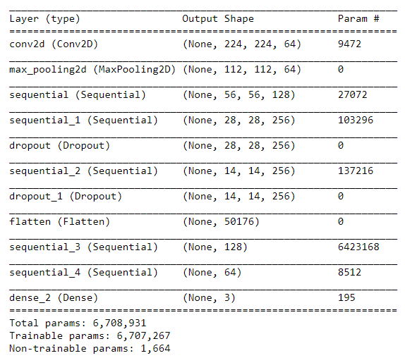

* The learning curves from the training phase are shown in the figure below.

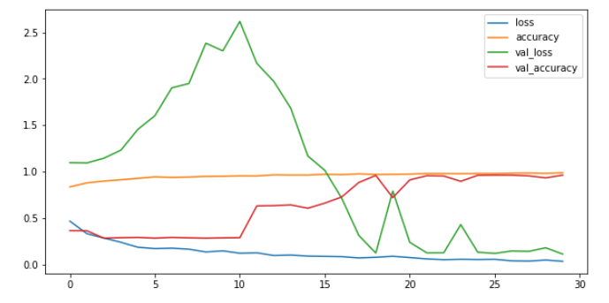

* The learning curves show that the optimal model is obtained somewhere between 23 and 30 epochs. The validation loss almost matches the training loss and similarly for the accuracy metric.
* The results as evaluated on the test set are shown in the table below. The base model was able to achieve a weighted average for all metrics of ~98%

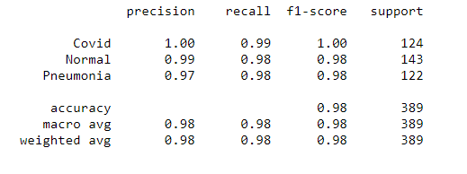

*Deep ConvNets*

* Transfer learning was done to leverage pre-trained and much deeper convnets trained on the popular imagenet dataset.
* The Inception-ResNet-V3 and Xception CNNs were trained on this problem (See repository for code details).
* With the Xception network, the weighted average of each metric was bumped up to ~99% with only 2 misclassifications on the test set.
* The learning curve for the training phase is shown in the figure below.

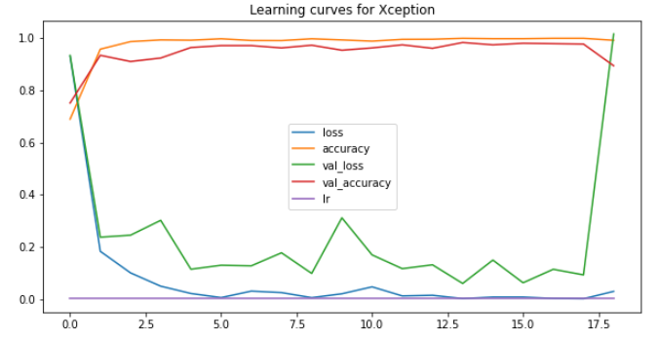

* With checkpoints, we’re able to ensure that the best model is saved before the model diverges during training as indicated by the ends of the learning curves.
* The test evaluation results for the Xception model are shown in the table below.

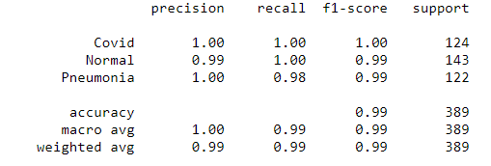

Model Interpretability

* Deep learning model interpretability is an active area of research that aims to ensure that we build transparent models that have the ability to explain why they predict what they predict.
* We explore model interpretability in this project with two approaches
* The first is by visualizing and analyzing the intermediate feature maps generated by the deep convnet from the earlier layers down to the final layer.
* The second approach is an algorithm called Grad-CAM [4] which stands for gradient-weighted class activation mapping.

*Intermediate Feature Maps*

* As we propagate the input image through the convnet, we can also take a deep dive and obtain the intermediate outputs to gain some intuitions about the workings of the convnet.
* The figure below shows select feature maps from the 1st, 90th, 153rd, and final convolution layers for a pneumonia test image. In the initial layers, the convnet identifies primitive features like edges, corners, color intensity, and so on. As we go deeper into the network, the neurons in later layers specialize and identify more high-level features that help in distinguishing between the target classes for prediction.

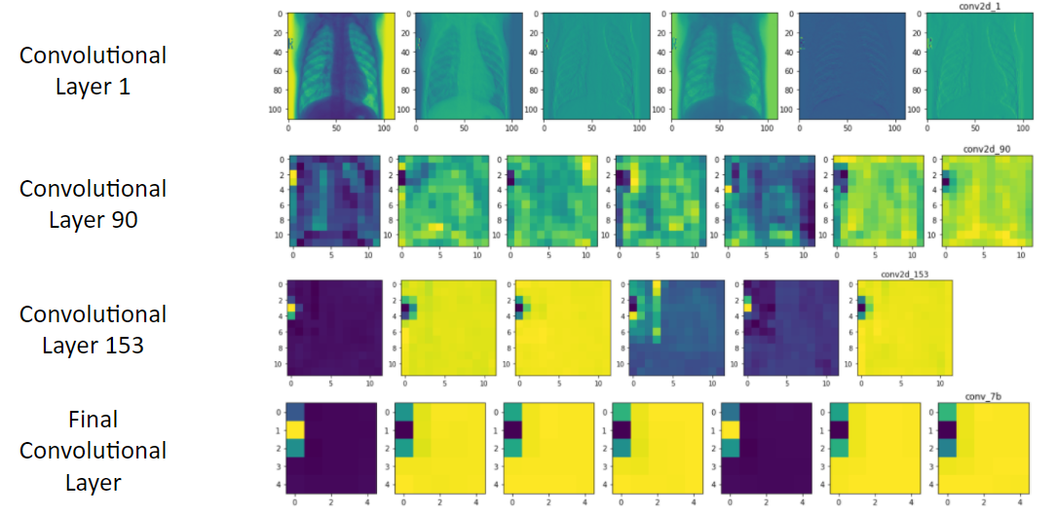

*Grad-CAM*

* With the Grad-CAM algorithm, we are taking the output feature map of a convolution layer given an input image, and weighing every channel in that feature map by the gradient of the class with respect to the channel. Intuitively, we are weighting a spatial map of "how intensely the input image activates different channels" by "how important each channel is with regard to the class", resulting in a spatial map of "how intensely the input image activates the class". Hence, we can obtain heatmaps for the channels in the final convolution layer that indicate the localized regions in the image that most intensely activates the predicted class.
* With this algorithm, we obtained the heatmaps for various test images in each class. A few of them are shown in the figure below. For heatmap intensity, blue maps to low and red maps to high with gradients in between. The heatmaps were superimposed with the X-ray images but because the heatmaps are RGB while the X-rays are grayscale, the heatmaps dominate the resulting image.

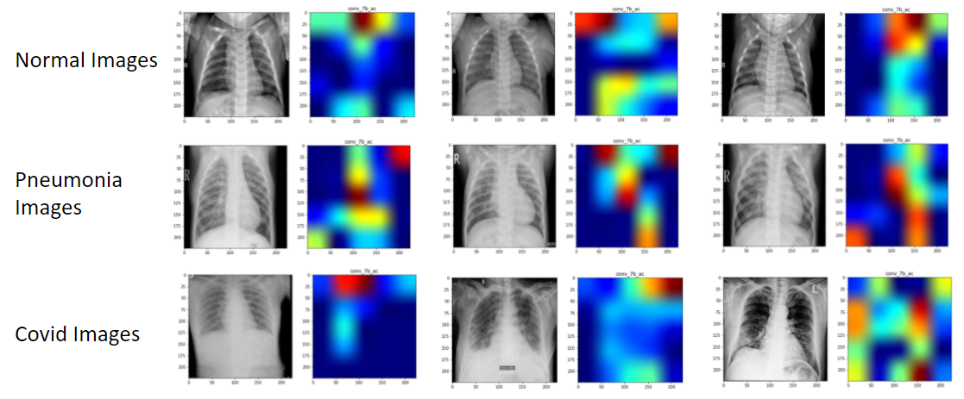

* With these results, we are able to ensure some element of trust in the workings of our model in solving this problem. This is especially vital for a project that is centered around a health sector problem. It is very important in such cases to explain the inner workings of a machine learning model since dealing with people’s lives is always very delicate and high-risk.

Model Deployment

* To deploy our final model as a web application, we used Flask alongside web design tools like HTML and CSS. It has features such as scroll-up, scroll-down, and anchoring.
* Flask is a microframework used to create web services in Python. For simple requirements, Flask lets you hit the ground running. It is among the best python web frameworks providing a vast array of libraries, tools, and modules for building web-applications.
* In our web app, the user is able to upload one or more images, make a prediction, and download the results as a csv file indicating the predicted class of the images and associated confidence of predictions.

*Running the Application*

1. Run the model_deployment.py in your terminal.
2. The website will be up and running on the server http://127.0.0.1:5000/.
3. Kindly follow the instructions below.

The layout of the website is sectioned as follows: a home page, an about section, and the covid-19 recognizer tool.

1. Home page: This page has two buttons that navigate the user to the about section and covid-19 recognizer section.

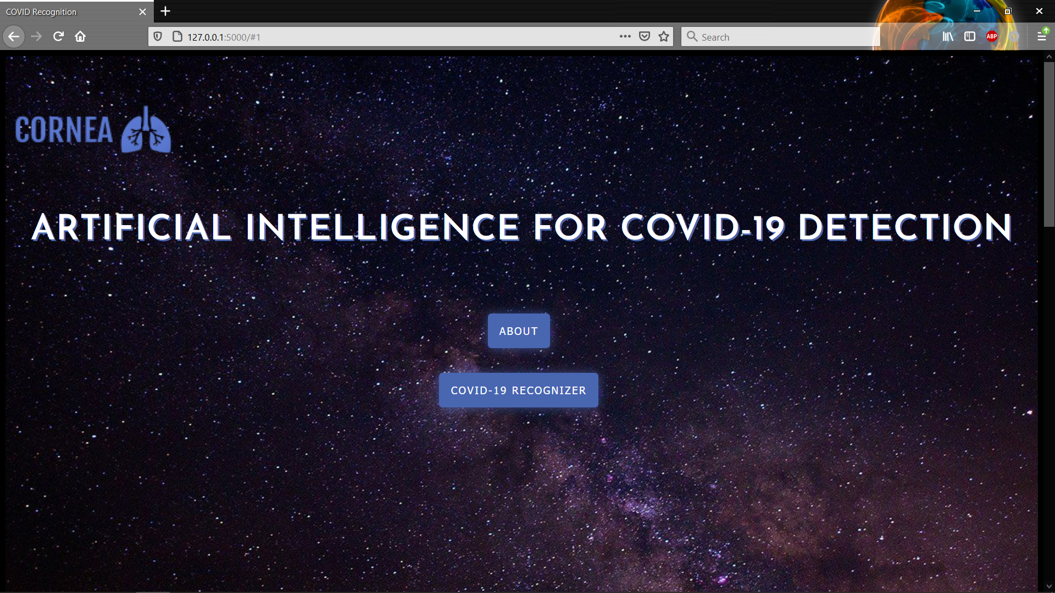

1. About Section: This section contains information about the application and the developers. There is a button at the bottom-center of the page which navigates us to the Covid Recognizer tool.

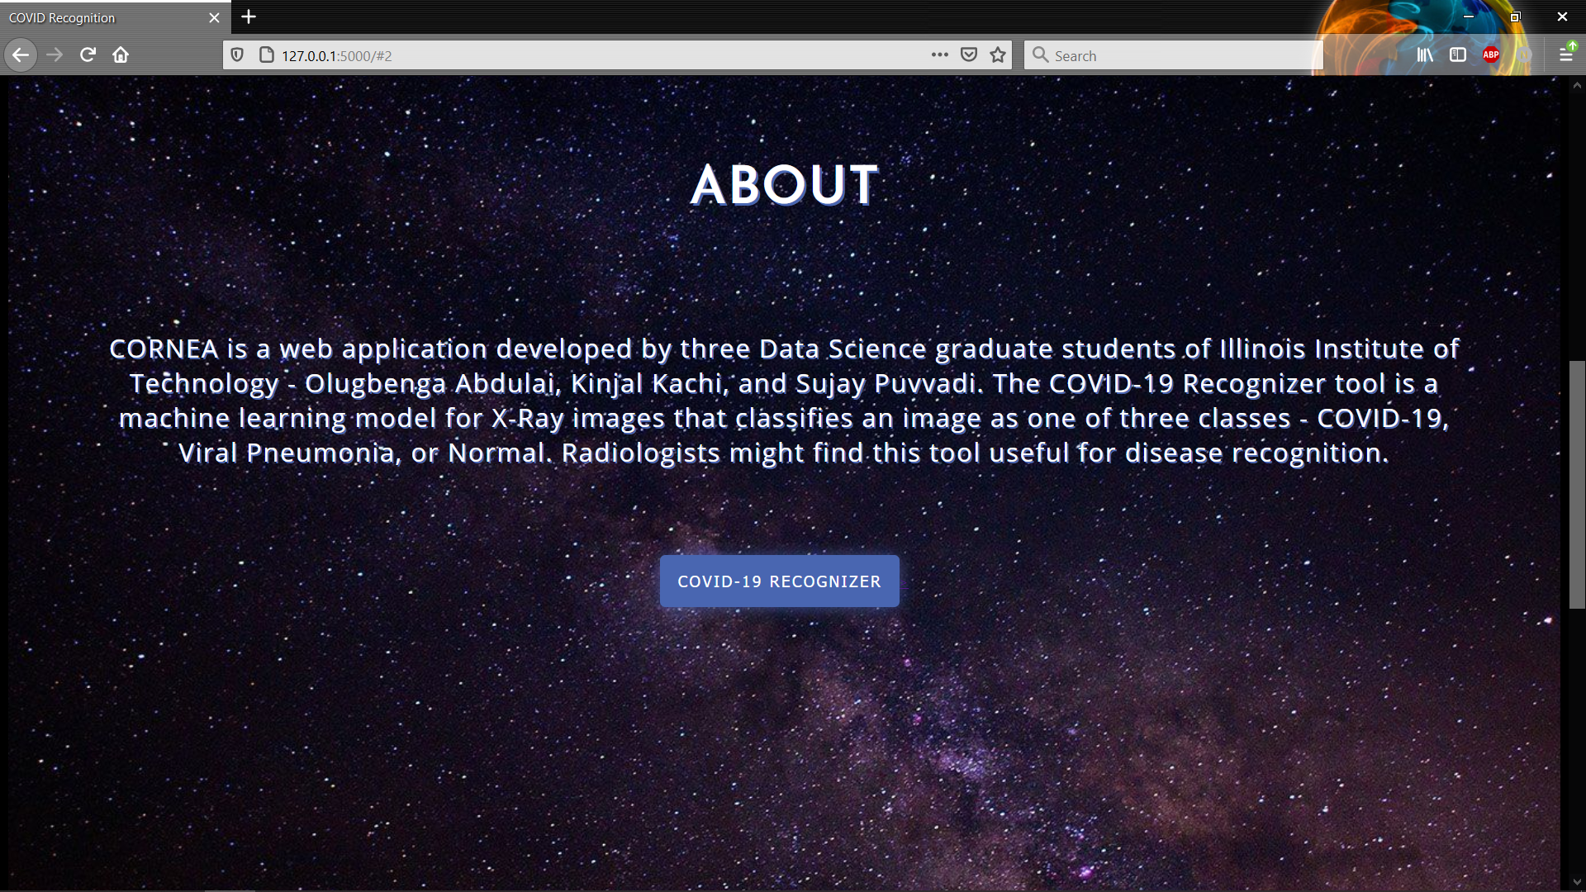

1. AI-driven Covid Recognition tool: This section has 4 buttons: **Choose Files,** **Upload, Predict,** and **Download.**

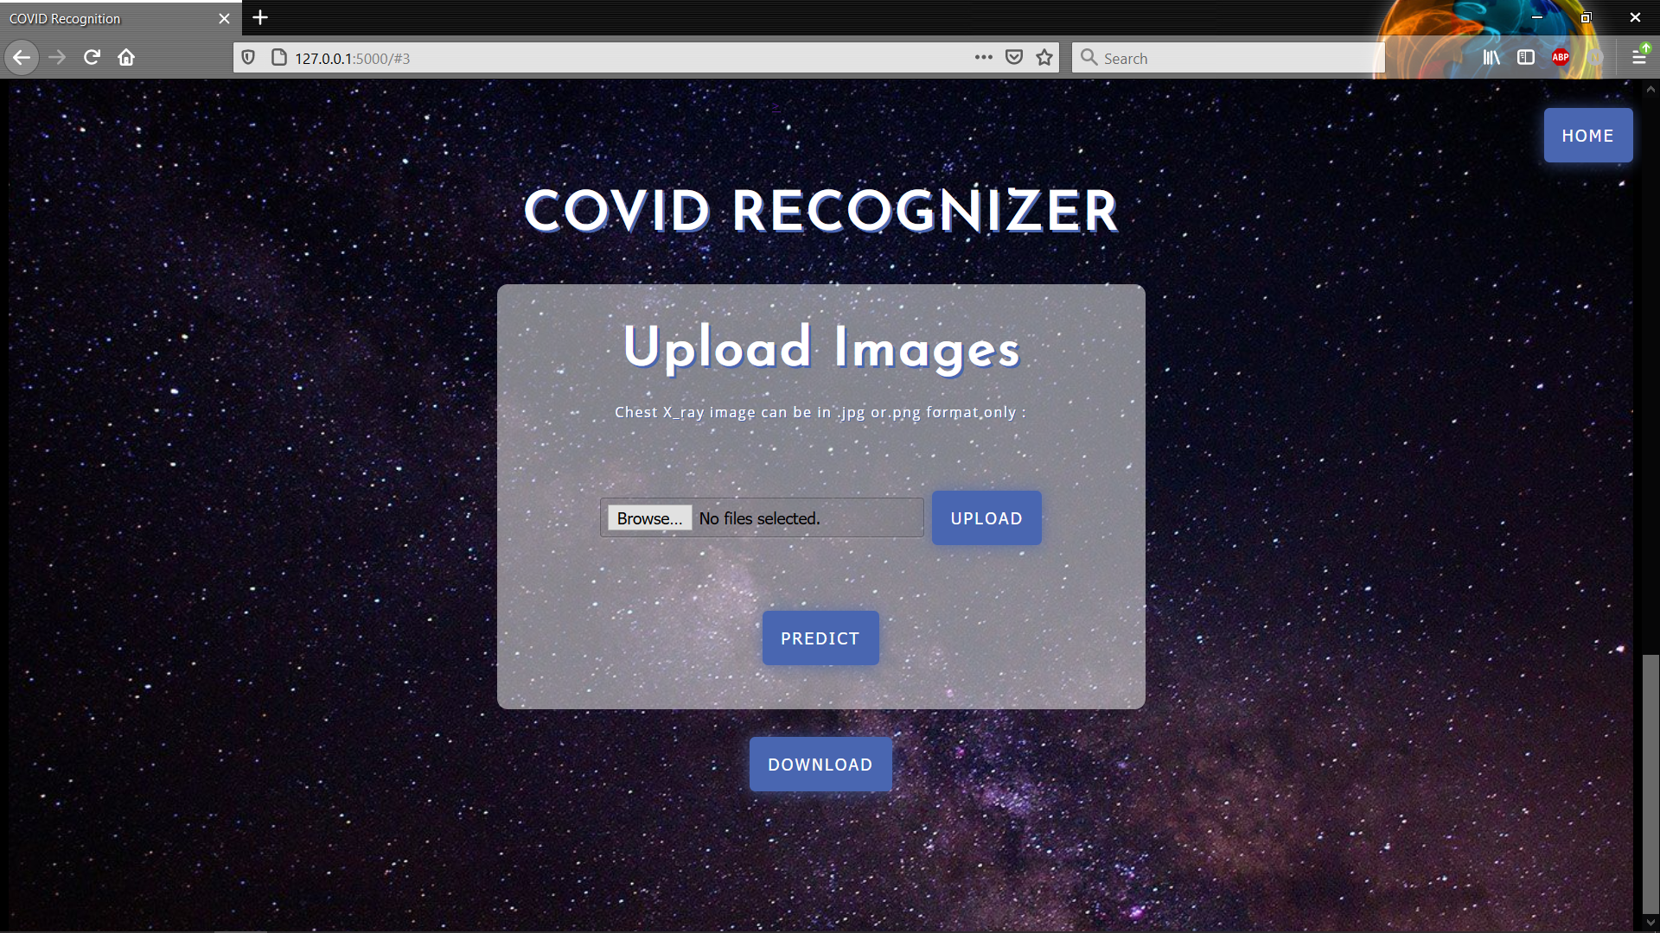

*Steps to use the tool*

1. Click the **Choose File** button and select one or multiple images of your choice.

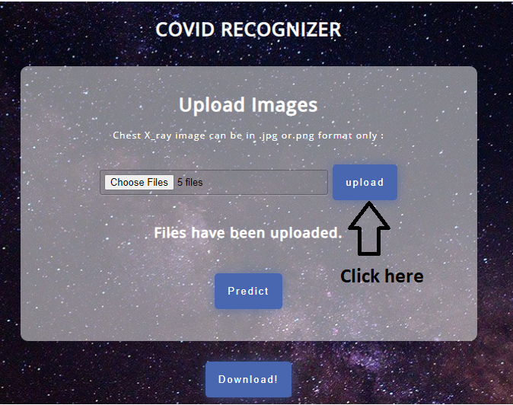

1. Then click the upload button, to upload the images, once the images have been uploaded you will get the message on the screen “Files have been uploaded.”
   1. What is happening in the background? Each time the user uploads images, the images are being passed to the local system from where the code is running. All these images are automatically saved in a folder, the batchid makes these folders unique, this batchid is basically the timestamp associated with the time of the upload. Hence, the images uploaded on date:04/17/2020 and 24-hour time format (hours + minutes + seconds + milliseconds): 8:23 p.m. are being saved in the folder named: “Save_data_**20210417192358481763**” in your local.

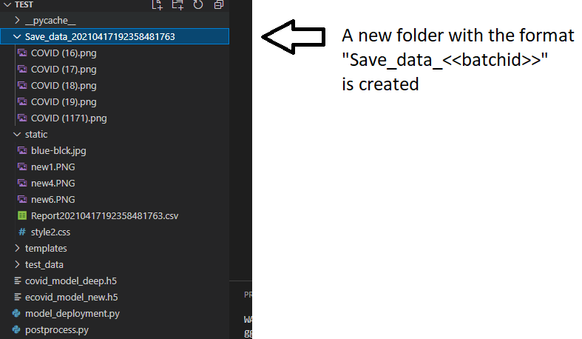

1. Use the Predict button to run the predictions. The images in the folder “Save_data_**20210417192358481763**” are picked up one by one, these images go through the pre-processing step then they are fed to the model, and predictions are written into a CSV file. The same naming convention is followed for the report name as for the folder creation: “Report<<batchid>>.csv”. The report is saved in your local directory with the name: “Report**20210417192358481763**.csv”. Once all the predictions are written to the CSV, the UI displays the message: “Predictions are ready for download”.

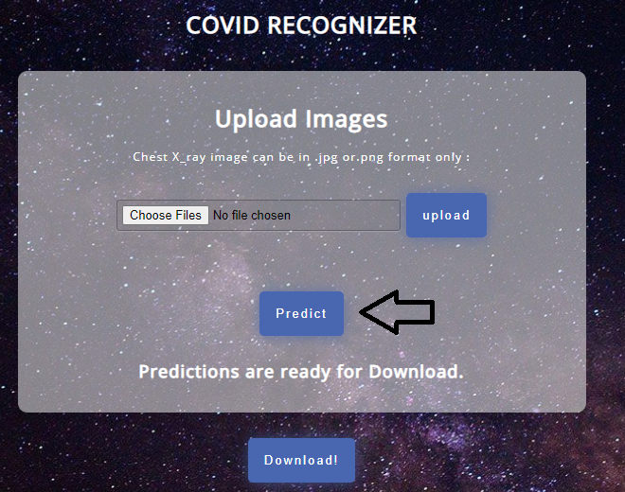

4. Use the Download button to download the results

## Quality Assurance

* Data quality and size: The data was sourced from Kaggle and was one of the most well-curated datasets available. The size of the data was also good enough to achieve meaningful results.
* Data splits: The data was split into training, validation and test sets, hence we enforced two levels of testing the models. First with the validation set, and finally with the test set.
* Modeling: We used state-of-the-art models for transfer learning. The best-performing model, Xception, is both a robust and optimized convnet. It is much less parameterized, using separable convolutional layers.
* Model Interpretability: We explore algorithms (discussed earlier) to build valid intuitions as to how the model works and why it makes the predictions that it does. This allows some element of trust in the model and is an active area of research in deep learning.
* Deployment: We appropriately tested the deployment phase of the project and it works as expected.

# Project Support

* We will remain available for possible improvements or suggestions on the results of this project. The code is available in a GitHub repository and will continually be updated if any new ideas come up.

# Project Retrospective

Describe the team’s thoughts on the lesson learned, suggestions for improvements, and any memorable moments on working on this project.

* Learning points: Some major learning points in this project include image analysis and manipulation, deep learning with convolutional neural networks, hyperparameter optimization, model selection, transfer learning, model interpretability, and web app deployment.
* Future scope
  + Some more research could be done on model interpretability beyond what we have provided in this project. As stressed earlier, it is an important area to explore especially for health use cases.
  + More robust deployment options that would scale to larger datasets could be explored. e.g. leveraging cloud machine learning provisions.
  + More data could be used to train the model.
* Memorable moments: Our weekly presentations with the Accenture team were always interesting because we would get some feedback then work on that against the next week. It was an interesting iteration of continuous improvement. We also learned about progress updates from teams working on other projects.

# References or Other Supporting Documents

[1] Xiaoxuan Liu et al. A comparison of deep learning performance against health-care professionals in detecting diseases from medical imaging: a systematic review and meta-analysis. In *Lancet Digital Health* 2019; 1: e271–97

[2] Covid-19 Radiography Database. [*https://www.kaggle.com/tawsifurrahman/covid19-radiography-database*](https://www.kaggle.com/tawsifurrahman/covid19-radiography-database)*.* 2021.

[3] Covid recognition. *https://github.com/Hackman-git/Covid-recognition*

[4] Ramprasaath R. Selvaraju et al. Grad-CAM: Visual Explanations from Deep Networks via Gradient-based Localization. In *International Journal of Computer Vision (IJCV)*, 2019

# Document Revision History

2/25/2021 – Prof. Lam – Initial Version

2/8/2021 – Sponsor – Sign off

5/1/2021 - Final version